CSA1505 - CLOUD COMPUTING AND BIG DATA ANALYTICS
Experiment-3

- Create a simple cloud software application for Flight Reservation System using any Cloud Service Provider to demonstrate SaaS include the necessary fields such as one way, round trip, From, to, Departure, Departure, Travelers & Class, Fare Type, International and Domestic Flights etc.

AIM:
To develop a simple Flight Reservation System using Zoho Creator (Cloud Service Provider) to demonstrate the Software as a Service (SaaS) model. The application allows users to book domestic and international flights by entering passenger and travel details.
PROCEDURE:
Log in to Zoho Creator.
Create a new application named Flight Reservation System.
Design a form with the following fields:
- Passenger Name
- Mobile Number
- Email
- Trip Type (One Way / Round Trip)
- From
- To
- Departure Date
- Return Date
- Travelers
- Travel Class
- Fare Type
- Flight Type (Domestic / International)
- Airline
- Fare
- Booking Status
- Booking Date

Configure drop-down lists and radio buttons for the required options.
Create a workflow to automatically set:
Booking Date = Current Date & Time
Booking Status = Booked
Save the application.
Run the application and enter sample reservation details.
Verify that the booking information is stored successfully.

INPUT:

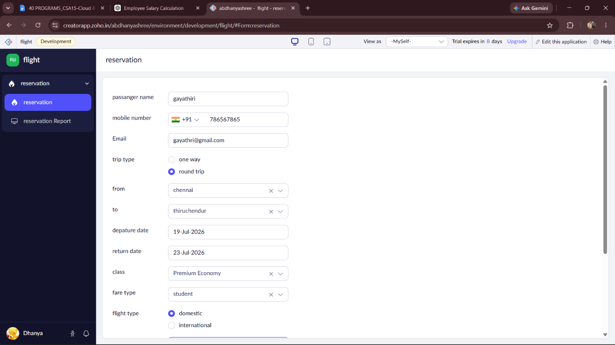

OUTPUT:

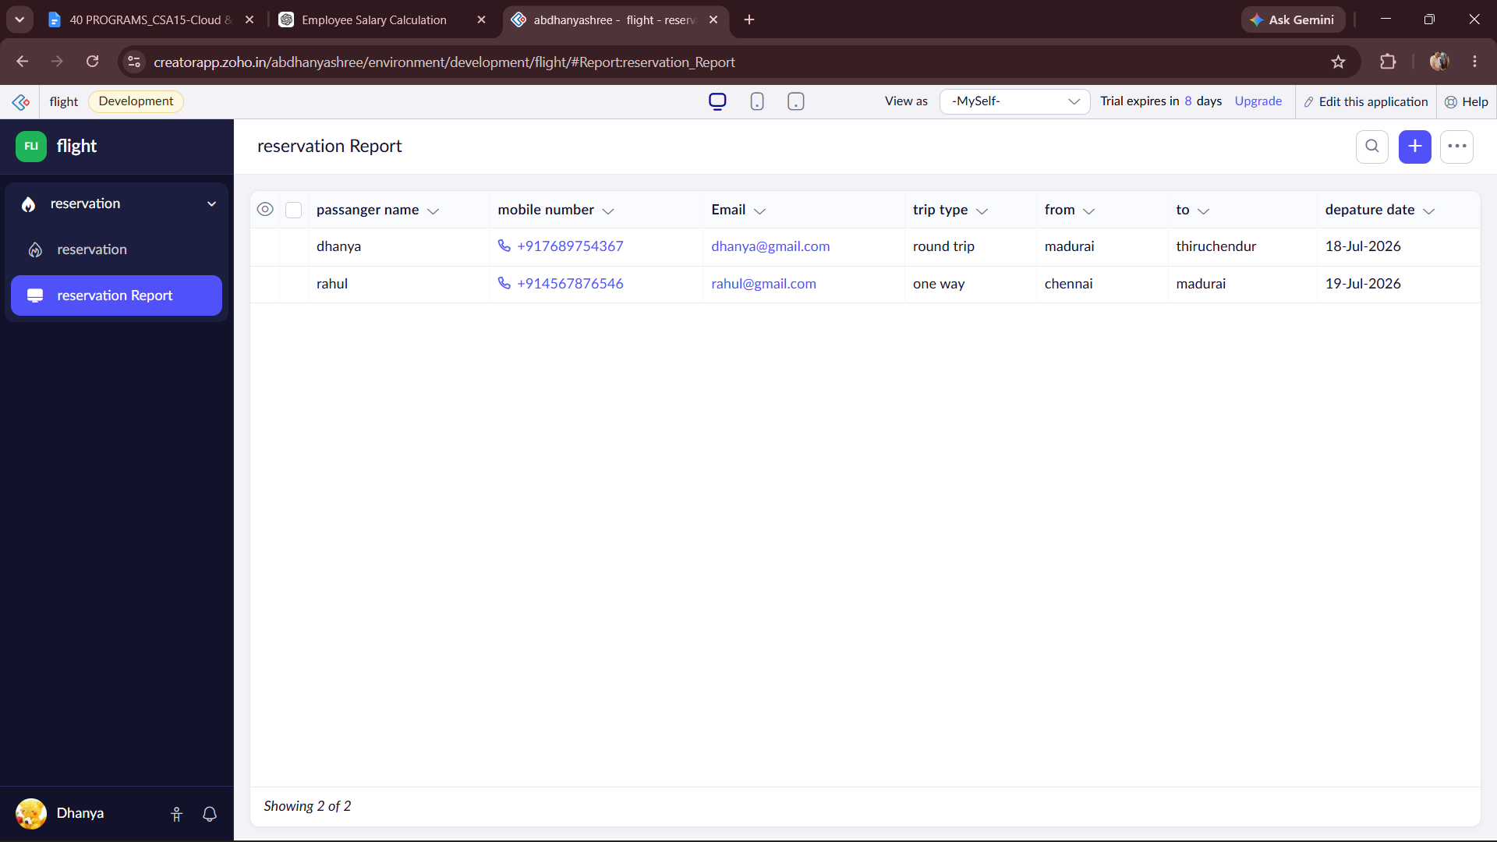

DESIGN:
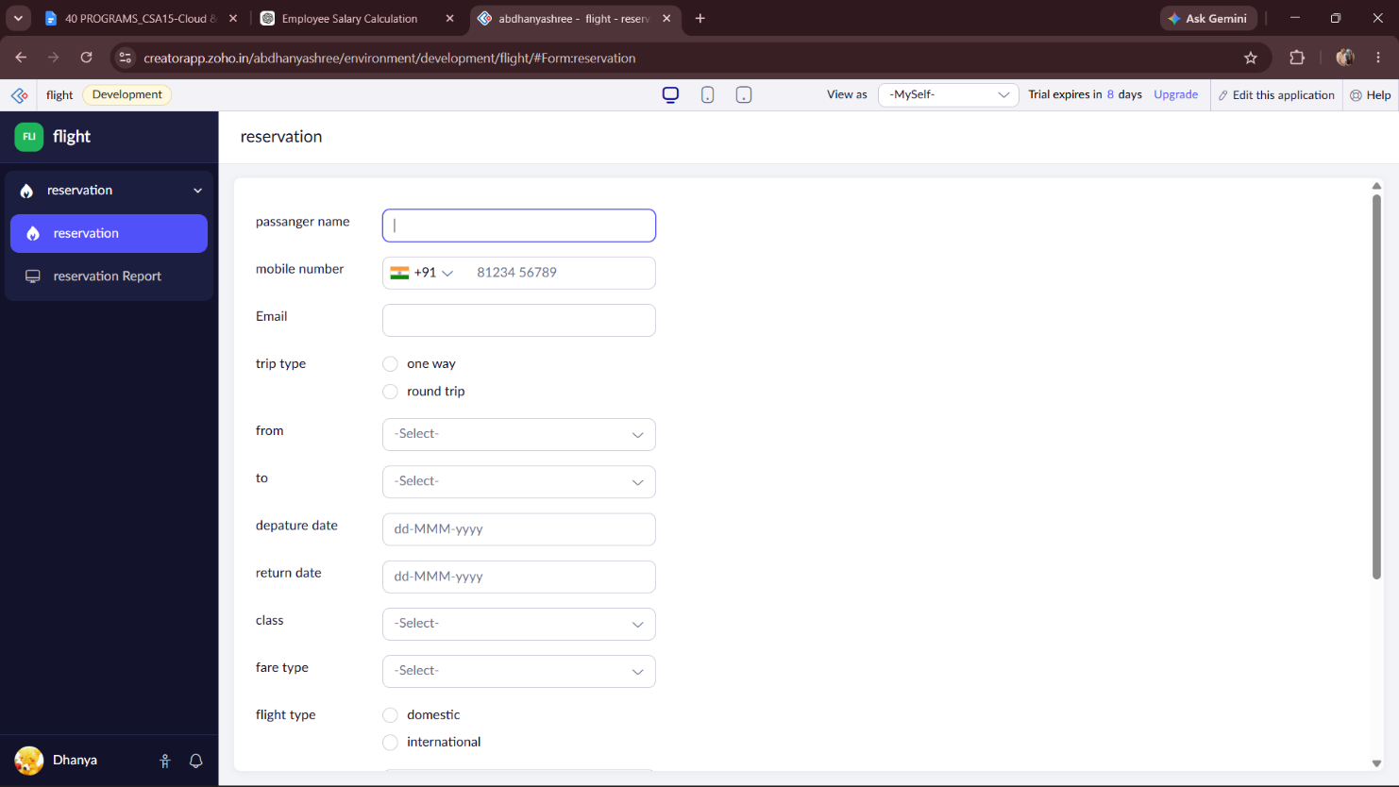
WORKFLOW:
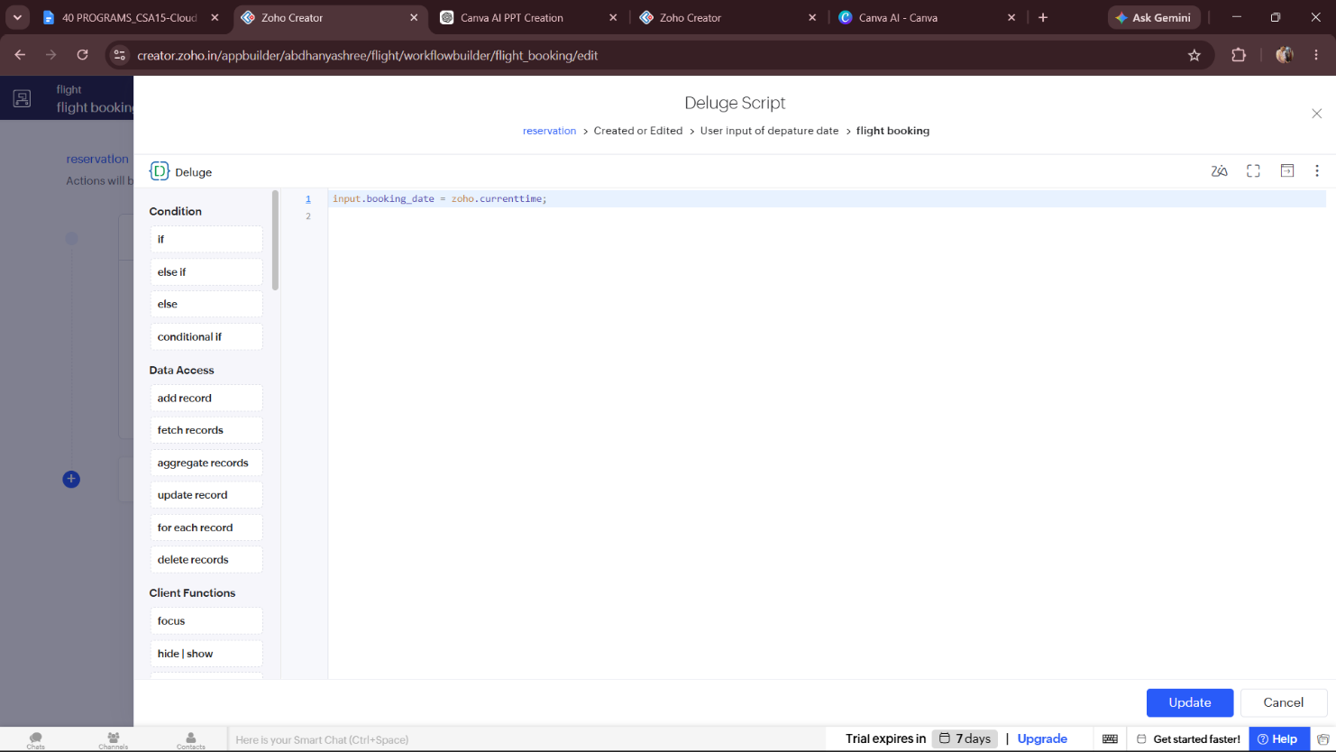

RESULT:
A cloud-based Flight Reservation System was successfully developed using Zoho Creator. The application enables users to book domestic and international flights by entering travel details. The booking date and booking status are updated automatically through workflows, demonstrating the SaaS (Software as a Service) model in cloud computing.

